**Field Work**

**On**

**Student Attendance Management System**

**Submitted**

**to**

**KCES’s Institute of Management and Research, Jalgaon**



**Submitted by**

**Name: Chetan Rajendra Mahajan**

**Email id: mahajanc1054@gmail.com**

**Name: Bagwan Atiqur Rehman Shaikh Zakir**

**Email id: atiqbagwan88@gmail.com**

**Under the Guidance of**

**Name**: **Mr. Prakash Bari**

**In Partial Fulfillment of**

**Master of Computer Application  (Integrated)**

**Kavayitri Bahinabai Chaudhari North Maharashtra University, Jalgaon**

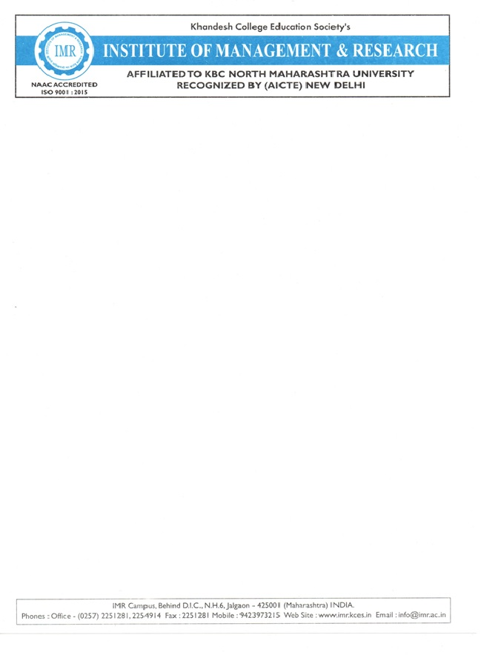

**CERTIFICATE**

This is to certify that **Mr. Chetan Rajendra Mahajan & Mr. Bagwan Atiqur Rehman Shaikh Zakir**

student’s of MCA(Integrated) from **KCES’S Institute of Management and Research,Jalgaon** has completed the Filed work s fulfillment of the requirement for the degree of MCA(Integrated) during academic year **2025-2026.**

It is the original work and sincerely completed the field work. I am fully satisfied

with his/there performance.

**Mr.prakash Bari Mr.prakash Bari**

**Internal Guide Coordinator**

**Dr.Mrs Deepali Kirange**

**External Examiner I / Examiner II HOD**

**ACKNOWLEDGEMENT**

 We have great pleasure in submitting this Field Work on Student Attendance Management System to Kavayitri Bahinabai Chaudhari  North Maharashtra University, Jalgaon.

 It is humble brief that any Field Work can be carried out with success by a two person. Many other personalities helpings to accomplished this project and it is our duty to express our appreciation to them.

 We are indebted to: **Mr. Prakash Bari** for helping us as guide and  allow us to do the Field Work at their site.

 We wish to thank the teaching staff, our friends and persons who help us directly or indirectly for completion of Field Work.

**DECLARATION**

We hereby declare that the project work entitled **“*Student Attendance Management*”** has carried out result on the basis of investigations and analysis by us under the guidance of **Mr. Prakash Bari.**

 We further declare that this work has not been submitted in partly or fully to any other University or Institute for the award of any other degree. Material obtained from other source has been daily acknowledged in the Field Work.

**INDEX**

|  |  |
| --- | --- |
| **Sr. No.** | **Topic** |
| 1 | Abstract |
| 2 | Introduction |
| 3 | Project Field Work Topic / Literature Review |
| 4 | Objectives |
| 5 | Methodology |
| 6 | Result and Discussion |
| 7 | Recommendations and Future Work |
| 8 | Suggestion |
| 9 | Conclusion |
| 10 | References |

1. **Abstract:**

The Student Attendance Management System is a software-based solution designed to automate and streamline the process of recording, managing, and analyzing student attendance. Traditional manual attendance methods are time-consuming, error-prone, and difficult to maintain. This system replaces manual registers with a digital platform that ensures accurate data collection and efficient record handling.

The system enables faculty to mark attendance quickly using web or mobile interfaces, while securely storing the data in a centralized database. It provides real-time attendance reports, student-wise records, subject-wise summaries, and automated calculations of attendance percentages. The system can also notify students and parents about low attendance and generate reports for academic departments.

By ensuring transparency, accuracy, and ease of access, the Student Attendance Management System enhances institutional productivity and minimizes paperwork. Overall, this system offers an efficient, reliable, and scalable solution for educational institutions to monitor student presence and improve academic management.

1. **Introduction:**

The Student Attendance Management System is a digital solution designed to efficiently record, track, and manage student attendance in educational institutions. Traditional methods of maintaining attendance — such as manual registers or paper-based sheets — are time-consuming, prone to human error, and difficult to analyze. To overcome these limitations, an automated system provides accuracy, reliability, and easy accessibility of attendance data.

This system allows teachers to mark attendance quickly using digital interfaces, while administrators can monitor attendance records in real-time. It can also generate reports, identify absentee trends, and help maintain discipline and performance consistency among students. By integrating technologies like Google Sheets, Google Apps Script, or database-driven web applications, the system ensures that data is securely stored and easily retrievable.

Overall, the Student Attendance Management System not only simplifies the attendance process but also enhances institutional efficiency, minimizes paperwork, and promotes transparency between teachers, students, and administrators.

1. **Project Field Work Topic / Literature Review:**

The Student Attendance Management System (SAMS) has been widely studied and implemented in educational institutions to modernize attendance tracking. Traditional attendance marking methods rely on manual entry using paper registers, which are prone to errors, loss of data, increased workload, and time consumption. Therefore, several studies have proposed automated solutions using web, mobile, biometric, and RFID technologies to make attendance monitoring more accurate and efficient.

Early research focused on manual-to-digital transformation, where attendance was stored in local computers or spreadsheets. These systems reduced paperwork but lacked real-time access and integration with institutional databases.

Later studies explored web-based attendance systems, enabling centralized storage, report generation, and teacher–student communication. Researchers found that digital systems increase accuracy, reduce manipulation, and allow faster reporting for internal assessments.

With advancements in technology, modern studies introduced biometric-based attendance systems such as fingerprint recognition, facial recognition, and iris scanning. According to these studies, biometric systems help prevent proxy attendance and ensure identity verification. However, they require higher installation costs and maintenance.

Other literature highlights the use of RFID (Radio Frequency Identification) cards, which allow students to scan ID cards to record attendance automatically. RFID-based models are fast and reliable but can still face challenges such as card sharing or system failure.

1. **Objectives:**
2. To Automate Attendance RecordingReplace manual attendance methods with a digital system that records attendance quickly and accurately.
3. To Reduce Human Errors  
   Minimize calculation mistakes, duplicate entries, or missing data that often occur in manual attendance systems.

3.To Save Time and Improve Efficiency  
 Enable teachers to take attendance within seconds and

automatically update records in the database

or spreadsheet.

4. To Provide Real-Time Access to Attendance Data  
 Allow teachers, students, and administrators to view

attendance details anytime and from anywhere.

5. To Generate Accurate Reports  
 Automatically create daily, weekly, or monthly

attendance summaries and performance reports.

**5. Methodology:**

1. System Analysis

In this phase, the existing manual attendance process is studied to identify its drawbacks such as time consumption, inaccuracy, and data redundancy. The system requirements — both functional and non-functional — are collected through discussions with teachers, administrators, and students. This helps define the system’s scope and objectives clearly.

2. System Design

Based on the analysis, the system architecture and database design are created. Input forms, dashboards, and attendance sheets are planned to ensure user-friendly interaction. The design phase focuses on defining:

* User interface (UI) design
* Database structure (for storing student and attendance records)
* Flow diagrams showing the data and process flow

3. System Development

In this phase, the actual coding or implementation takes place. Depending on the platform, technologies such as:

* Google Sheets and Google Apps Script, or
* Web technologies (HTML, CSS, JavaScript, PHP, MySQL)  
  are used to create the system. The goal is to build features for marking attendance, updating records, and generating reports automatically.

**6.RESULT AND DISCUSSION:**

**Results**

The implementation of the Student Attendance Management System (SAMS) demonstrated a significant improvement in attendance recording efficiency and data management. Key findings include:

1. Faster Attendance Recording:  
   The time required to record attendance was reduced by approximately 60–80% compared to manual register entries.
2. Improved Accuracy:  
   Errors such as missing entries, duplication, or incorrect calculations were eliminated due to automated data processing.
3. Centralized Data Storage:  
   All attendance records were stored in a central database, making them easily accessible for teachers and administrators.
4. Real-Time Reports:  
   The system generated instant reports on daily, weekly, and monthly student attendance. Attendance percentage calculations were automatically updated.
5. Notification System (if implemented):  
   Students and/or parents were able to receive alerts for low attendance, helping them keep track of academic requirements.

**Discussion**

The results of this study confirm that automated attendance systems significantly improve institutional efficiency. Traditional paper-based systems are slow, prone to human error, and often difficult to manage over long periods. The developed system overcomes these limitations by digitizing the entire attendance process.

The reduction in processing time highlights the system’s ability to enhance classroom management, allowing teachers to focus more on teaching rather than administrative tasks. Additionally, the improved accuracy of records facilitates fair evaluations of student participation and academic progress.

**7.Recommendations and Future Work**

**Recommendations**

Based on the implementation and evaluation of the Student Attendance Management System (SAMS), the following recommendations are proposed to enhance performance and usability:

1. Provide User Training:  
   Educators and administrative staff should be trained to use the system effectively to ensure smooth adoption and reduce operational errors.
2. Regular Data Backup:  
   The system should be integrated with regular backup features to prevent data loss due to system failure or cyber-threats.
3. Implement Multi-Device Accessibility:  
   The system should support desktop, mobile, and tablet access to improve convenience for teachers and students.
4. Improve Network Reliability:  
   Institutions must ensure stable internet connectivity to allow seamless system operation, especially if the system is cloud-based.

**Future Work**

Several enhancements can be incorporated into the system to increase its capabilities and adaptability in the future:

1. Biometric and AI-Based Attendance:  
   Integration of biometric technologies such as facial recognition, fingerprint scanning, or iris detection to prevent proxy attendance and strengthen security.
2. Machine Learning Analytics:  
   Implementation of AI models to predict attendance patterns and identify students at risk of poor attendance.
3. Cloud-Based Integration:  
   Full cloud storage and processing to increase scalability, real-time synchronization, and access from remote locations.

**8.Suggestion:**

According to all the responses there are some major suggestion are as follows:

1. **Integration with Biometric or RFID Systems**  
The system can be enhanced by integrating biometric scanners or RFID card readers to automatically record student attendance and eliminate proxy marking.

2. **Mobile Application Development**  
Creating a dedicated mobile app for teachers and students can make attendance marking, viewing reports, and receiving notifications more convenient and accessible.

3 .**Automated Notification System**  
The system can be improved by adding SMS or email alerts to inform parents or guardians about a student’s absence or irregular attendance.

4. **Data Analytics and Reporting Tools**  
Advanced data visualization and analytics features can help administrators identify attendance trends, frequent absentees, and correlations with academic performance.

5 .**Cloud-Based Storage and Backup**  
Implementing cloud storage ensures data safety, remote access, and automatic backup of attendance records to prevent data loss.

**9.Conclusion**

The Student Attendance Management System successfully achieves its goal of automating and streamlining the attendance process in educational institutions. By replacing manual attendance methods with a digital system, it reduces paperwork, minimizes human errors, and saves valuable time for teachers and administrators.

The system provides accurate, real-time attendance data and generates useful reports for monitoring student performance and discipline. With features such as data storage, automatic calculation, and easy retrieval of records, it ensures improved efficiency, transparency, and reliability in attendance management.

Furthermore, the project demonstrates how technology — such as Google Sheets, Google Apps Script, or database-driven applications — can be effectively utilized to create a smart and sustainable solution for educational management tasks.

In conclusion, the implementation of the Student Attendance Management System not only modernizes the traditional attendance process but also contributes to better decision-making, improved institutional management, and enhanced student accountability.

**10.References:**

**Web References:**

* Google Developers — https://developers.google.com/apps-script
* W3Schools — https://www.w3schools.com
* GeeksforGeeks — https://www.geeksforgeeks.org
* TutorialsPoint — https://www.tutorialspoint.com
* ResearchGate — <https://www.researchgate.net>

**Github Repository:**

.**Word File Link**

<https://github.com/mahajanc1054-web/Student-Attendance-Management.../blob/main/Student%20Attendance%20Management%20Report%20(1).docx>

.**Excel File Link**

https://github.com/mahajanc1054-web/Student-Attendance-Management.../blob/main/Response%20excel%20file.xlsx

**Questionnaire:**

